

**National University**

**of Computer & Emerging Sciences Peshawar Campus**

Student Name: _____________________ Roll No: __________________

Examination: Finals

Total Marks: 60 Weightage: 40 %

Date: 24th June, 2020

Instructor: ­­ Mashal Khan

Program: ­­­BS Computer Science

Semester: Spring-2020

Time Allowed: 03 hours

Course: Object Oriented Programming CS217

**NOTE:** Attempt all questions.

Plagiarized work will be marked zero.

**Question # 01: [15 Marks]**

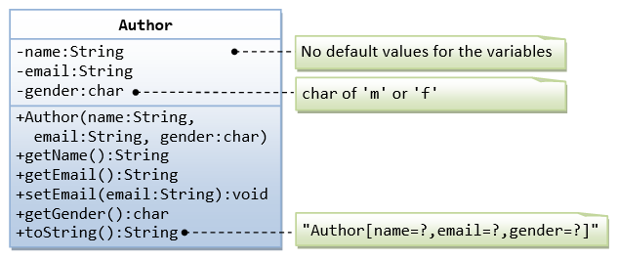

A class called Author (as shown in the class diagram) is designed to model a book's author. It contains:

* Three private instance variables: name (String), email (String), and gender (char of either 'm' or 'f');
* One constructor to initialize the name, email and gender values
* (There is no default constructor for Author, as there are no defaults for name, email and gender.)
* Public getters/setters: getName(), getEmail(), setEmail(), and getGender();  
  (There are no setters for name and gender, as these attributes cannot be changed.)
* A toString() method that returns "Author[name=?,email=?,gender=?]", e.g., "Author[name=Tan Ah Teck,email=ahTeck@somewhere.com,gender=m]".

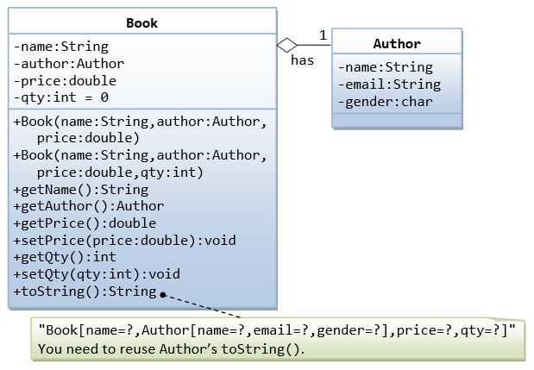

A class called Book is designed (as shown in the class diagram) to model a book written by one author. It contains:

* Four private instance variables: name (String), author (of the class Author you have just created, assume that a book has one and only one author), price (double), and qty (int);
* Two constructors:

public Book (String name, Author author, double price) { ...... }

public Book (String name, Author author, double price, int qty) { ...... }

* public methods getName(), getAuthor(), getPrice(), setPrice(), getQty(), setQty().
* A toString() that returns "Book[name=?,Author[name=?,email=?,gender=?],price=?,qty=?".  You should reuse Author’s toString().

**Questions:**

1. Write the Author class. Also write a test driver called TestAuthor to test all the publicmethods **[4 Marks]**
2. Write the Book class (which uses the Author class written earlier). Also write a test driver called TestBook to test all the public methods in the class Book. Take Note that you have to construct an instance of Author before you can construct an instance of Book**. [6 Marks]**
3. In Main() Print the name and email of the author from a Book instance. **[2 Marks]**
4. Introduce new methods called getAuthorName(), getAuthorEmail(), getAuthorGender() in the Book class to return the name, email and gender of the author of the book. **[3 Marks]**

**Question # 02: [10 Marks]**

**Part 1:** **[5 Marks]**

Specify the types of inheritance (Multiple, Multilevel, Hierarchical) used and show diagrammatically.

**Code:**

#include <iostream>

using namespace std;

**class Animal{**

public:

Animal()

{

Cout<<”this is an animal class”<<endl;

}

};

**class Mammal :public Animal{**

public:

Mammal()

{

cout << "Mammals can give direct birth." << endl;

}

};

**class WingedAnimal :public Animal {**

public:

WingedAnimal()

{

cout << "Winged animal can flap." << endl;

}

};

**class Bat: public Mammal, public WingedAnimal {**

public:

Bat()

{

Cout<<”Bat is a mammal as well as winged animal.”<<endl;

}

};

int main()

{

Bat b1;

return 0;

}

**Part 2:** **[5 Marks]**

Which data structure (Linked List, Stack, Queues) should be used for the following cases and why (1 lines)?

1. Undo functionality in Photoshop or Word.
2. Personal Computers, where multiple applications are running.
3. If Total Number of Elements in Array changes frequently.
4. Implementation of stacks and graphs.
5. Back/Forward on browsers.
6. Serving requests on a single shared resource, like a printer, CPU task scheduling etc.

**Question # 03: Case Study [25 Marks]**

**Problem Statement:**

Visual Horizon Software Solutions is a small scale training company wants to develop a web application for their employee’s management, initial days their business is limited to few cities with in a state and they maintained their employee’s information in XL Sheets. After few successful years their business is grown and started the company as a Pvt Listed Company now they are in the focus of their business expansion.

In VHSS there are different types of employees like Permanent, Contract, Hourly Based employees working for different designations. The list of designations were Technical Trainer, Soft Skill Trainer, Admin and Human Resources Team (i.e. HR) respectively.

All the employees were working for different departments based on their designation, following are the Departments.

1) Training

2) Admin

3) HR

Assume VHSS Team contacted a service provider company (XYZ) for this requirement, after requirements analysis XYZ Company divided the project into different modules and you are responsible for one entire module implementation, testing, integration and Knowledge Transfers. The list of modules was listed below.

1) Employee Registration Module

2) Department Activities Module

3) Training Activities Module

4) Reports Module.

Find below the tables which are used in this module.

**Table 1: VHSS_Employee_Details**

**Fields :**

EmpNumber – Primary key

EmpName

EmpJob

EmpType

EmpDoj

EmpSal

EmpDeptNo – Foreign Key

PossPortNumber - Foreign Key

**Table 2: VHSS_Department_Master**

**Fields**:

DeptNumber – Primary Key

DeptName

DeptLocation

**Table 3: VHSS_Emp_Address_Details**

**Fields**:

PossPortNumber – Primary Key

CountryName

CityName

VillageName

PinCodeNumber

**Questions:**

1. Identify and list all classes, data members and member methods. **[5 Marks]**
2. Identify and list all Abstract Classes, Sub Classes, Abstract Methods, and Dependent Classes. **[5 Marks]**
3. Identify the phenomenon (Inheritance, Composition, polymorphism) used and provide a single line justification for your answer. **[5 Marks]**
4. Write C++ code for all classes identified. **[10 Marks]**

**Question # 04: [10 Marks]**

A typical memory representation of C program consists of following sections.

1. Text segment  
2. Initialized data segment  
3. Uninitialized data segment  
4. Stack  
5. Heap

**Part 1:** **[4 Marks]**

For the following program Identify the sections where the following highlighted variables are stored.

**Code:**

#include<iostream>

using namespace std;

**int x = 0;**

**static int count=1, z;**

**const char a=”A”;**

int main()

{

**int s= new int;**

**int y = 10;**

**const char b=”B”;**

**static int c=6;**

cout << "Value of x is " << ::x;

cout<< "\nValue of y is " <<y;

return 0;

}

**Part 2:** **[6 Marks]**

Draw the memory diagram for the following recursive function (**void print(int p)**) and show the storage of variables in stack for the following program.

**Code:**

#include <iostream>

using namespace std;

void print(int p)

{

if (p==0)

return;

cout<<p;

print(p-1);

return;

}

int main(){

int a=2;

print (a);

system(“pause”);

return 0;

}